**Lesson Plan**

Sections of a Cube

**Objectives:**

1. To help students visualize the sections of a cube forming a square, rectangle, equilateral triangle, and regular hexagon with a physical, visual, 3D printed object.
2. To interest students’ in the wonders of 3D geometry by showing a compendium of other geometric sections a cube provides organized into discussing topics.

**Notes:**

Because cross-sections are fundamental to the understanding of planar geometry and the solids built around them, this lesson can stand alone, be divided, or even fragmented to augment multiple lessons on various topics. For younger students, naming the shapes, and associating them with their colors will probably be enough. Older students can use this cube as visualizing tool for solid geometries. To accommodate this loose planning structure, I have organized the lesson around discussing topics, which go deeper into the properties of each section, show related sections not in the printed cube with diagrams and descriptions, and give questions teachers can ask as assignments or discussion starters. Feel Free to rearrange or restructure the lesson as needed to suite the students’ age and your time and teaching style.

Happy Teaching

**State Standards:**

(Indiana State Standards are used)

GRADE 1:

1.G.1: *Identify objects as two-dimensional or three-dimensional. Classify and sort two-dimensional and three-dimensional objects by shape, size, roundness and other attributes. Describe how two-dimensional shapes make up the faces of three-dimensional objects.*

GRADE 2:

2.G.1: *Identify, describe, and classify two- and three-dimensional shapes (triangle, square, rectangle, cube, right rectangular prism) according to the number and shape of faces and the number of sides and/or vertices. Draw two-dimensional shapes.*

Geometry:

G.TS.9: *Identify the shapes of two-dimensional cross-sections of three-dimensional objects, and identify three-dimensional objects generated by rotations of two-dimensional objects.*

**Introduction:**

Show students the cube and the different colored sections.

**Class Notes:**

For younger students, associating shape and color may be enough. You may want students to draw or trace the shapes or run a finger along the shape to remember it.

**Sections and Properties:**

Square:

A four-sided polygon with sides of equal length, and all internal angles equal to 90·. (A regular quadrilateral.)

Discussion Topic:

The square is the corner stone of the cube and students should be familiar with their relationship. Show students how slicing parallel to any face will produce a square and ask students if there are any other ways to get a square. *(There are! A section parallel to an edge can also produce a square.)*

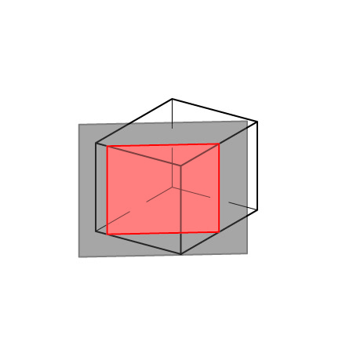

Rectangle:

A quadrilateral with opposite sides of equal length and all internal are 90·.

Discussion Topic:

The cube’s section is taken laterally across the cube producing a *silver rectangle* (where the ratio of the sides is 1: $\sqrt{2}$). Show how the section plane can be rotated around the intersecting edge to produce rectangles with ratios ranging from 1:1 (square, parallel to a face) to 1: $\sqrt{2}$ (silver rectangle, diagonal). Have students search for rectangles of a higher ratio. (*This is possible by intersecting the cube parallel to an edge through two adjacent sides as illustrated. (The square obtained above is just a rectangle with a special equilateral condition applied. This may help students see the infinite fluidity of sections, rather than as a series of distinct shapes. See also the discussion on the hexagon below.)*

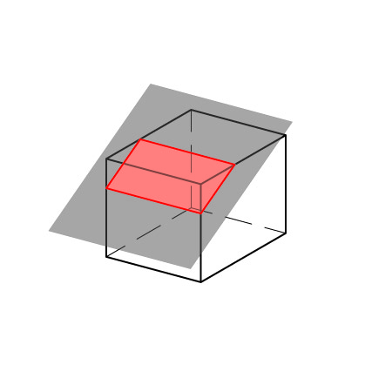 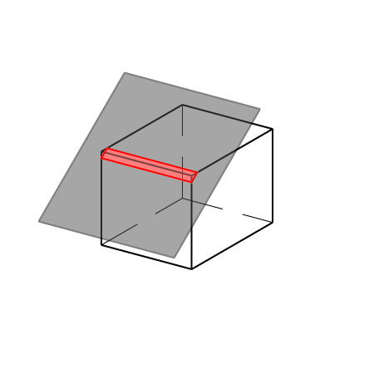

Ratio 1:2 Ratio 1:10

Triangle:

*A three-sided polygon with sides of equal length, and all internal angles equal to 60·.*

Discussion Topic:

While this section shows an equilateral triangle, it is possible to section a wide variety of triangles provided that each corner is less than 90·. Let students experiment by finding a number of triangles, then ask students to find a right triangle, or ask them why it can't be done. (*To get a 90· corner you would need to slice along the face of a cube, this will of course produce a square.)*

Regular Hexagon:

*A six-sided polygon with sides of equal length and internal angles of 120·.*

Discussion Topic:

This section may surprise students. Good, this may fire their imagination and inspire them to experiment with sections of their own.

Note that this section is taken through the midpoints of the sides to create a *regular* Hexagon. Ask students what would happen if you translate the section plane parallel to its current position? (*Three of the sides would get larger while the other three grow larger until the plane passes through the three lateral corners of the cube where the length of the three short sides becomes nothing and the shape becomes an equilateral triangle. Past this point the triangle retains its shape but grows smaller*.)

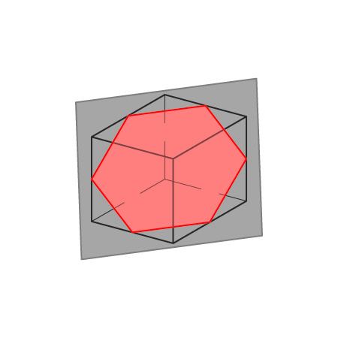 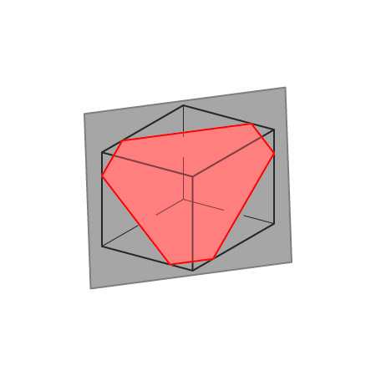

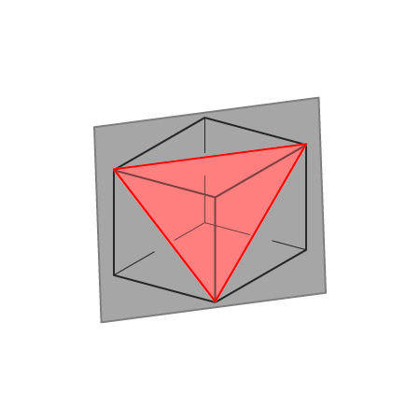 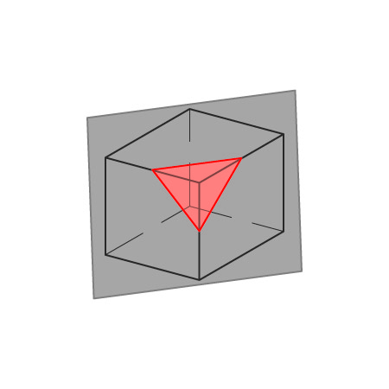

Sections Progressing from Regular Hexagon through Triangle

*Continued:*

Ask students what would happen if the section plane was rotated.

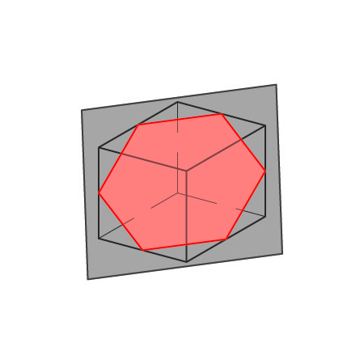

Regular Hexagon

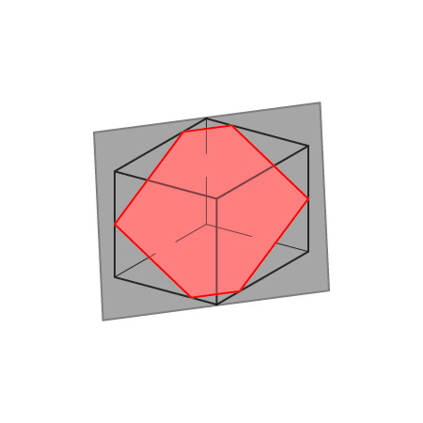

Section rotated about the horizontal

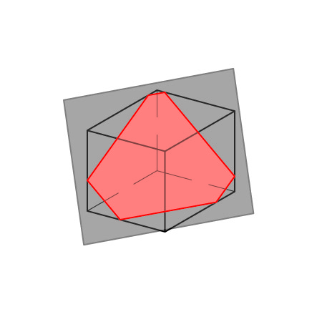

Section rotated about the Horizontal and vertical

Other Sections:

Discussion Topic:

There are an infinite number of ways to section a cube, but a 3D printed cube of infinite infinitely small sections is impossible. So, I had to choose sections based on printability and constructability. Here are some more. You can point them out to students, or have them find them. Google SketchUp or another free and easy-to-learn modeling software might be a useful resource in preparing students to think spatial about geometry, and might aid them with future geometric sections.

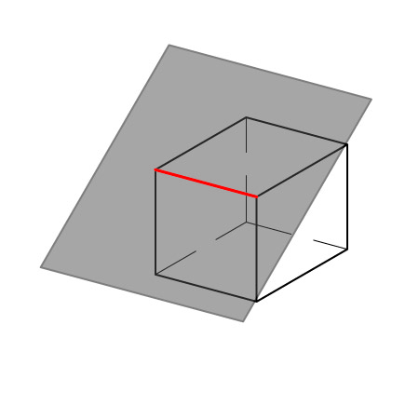 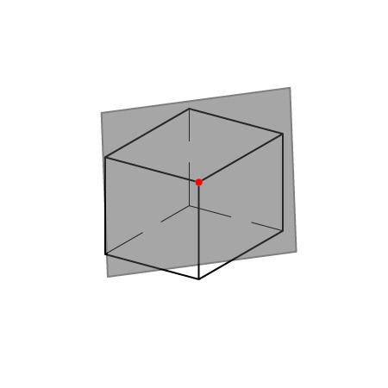

Line Point

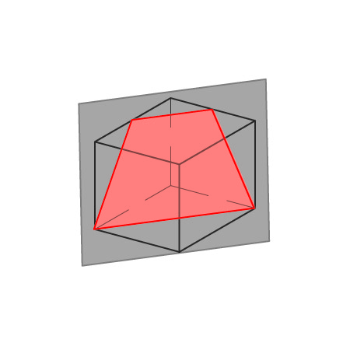 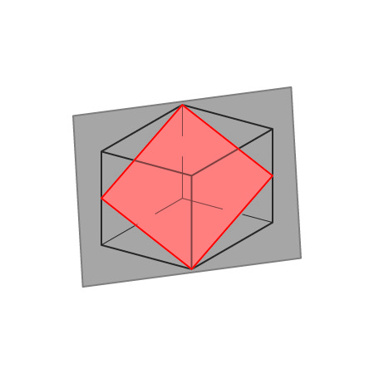

Trapezoid Rhombus

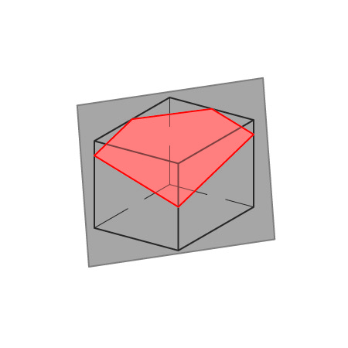

Irregular Pentagon

Good luck, and happy learning.